**Perceptual Decision Making**

**Question 1:**

**Part i:**

Conditional Independence of $r_{T}$ relative to $s$ can be shown via:

$$Pr\left(x,y | z\right)=Pr\left(y | z\right)Pr(x|z)$$

Expand out to all t $∈\left[1…T-1\right]:$

$$Pr\left(r_{t},r_{t+1} | s\right)=Pr\left(r_{t} | s\right)Pr(r_{t+1}|s)$$

Apply the Log to both sides of the equation:

$$Log[Pr\left(r_{t},r_{t+1} | s\right)]=Log\{Pr\left(r_{t} | s\right)Pr\left(r_{t+1} | s\right)]$$

Apply The Log rule:

$$Log[Pr\left(r_{t},r_{t+1} | s\right)]=Log[Pr\left(r_{t} | s\right)]+Log[Pr\left(r_{t+1} | s\right)]$$

**Part ii:**

$Log\frac{P(s1|x1…xt)}{P(s2|x1…xt)}=Log\frac{P\left(xt | s1\right)P(s1)}{P\left(xt | s2\right)P(s2)}=ΣLog\frac{P(xt|s1)}{P(xt|s2)}+ΣLog\frac{P(s1)}{P(s2)}$

$=\left[ΣLog P\left(xt | s1\right)-ΣLogP\left(xt | s2\right)\right]+[ΣLog P\left(s1\right)- ΣLog P(s2)]$

Where by the log rules:

$$Ln\left(xy\right)=\ln\left(x\right)+\ln\left(y\right)$$

$$Ln\left(\frac{x}{y}\right)=\ln\left(x\right)-ln⁡(y)$$

Continue To Next page

**Part iii:**

Following the logic of established in part ii:

$$Log\frac{P(s1|x1…xt)}{P(s2|x1…xt)}=$$

$$\left[ΣLog P\left(xt | s1\right)-ΣLogP\left(xt | s2\right)\right]+[ΣLog P\left(s1\right)- ΣLog P(s2)]$$

One can see that a uniform prior probability of S1 and S2 will cancel each other out and yield 0 when added in contribution to the log posterior ratio.

Iv: Likewise, a non-uniform prior will indeed provide a contribution when added to the

log posterior ratio. As the difference between Log P(S1) and Log P(S2) are assessed via subtraction, high priors biased to towards S1 will yield a large positive difference, whilst the Visa Versa will yield larger negative differences. The same principal applies to the difference between Log likelihood of P(xt|S1) & P(xt|S2). If the value of P(xt|S1) is greater than the value of P(xt|S2) then result increase the random walk positively towards S1, whilst if the value of P(xt|S2) is larger than P(xt|S1) the output will decrease the random walk negatively towards S2. Overall the addition of the priors will amplify or dampen the difference between P(xt|S1) – P(xt|S2) with varying magnitude relative the size of the difference between priors.

Continue To Next page

**Question 2:**

The effect Sigma/Standard deviation on the Dynamics of random Walk analysis:

***Figure 1: The Effects of Sigma***

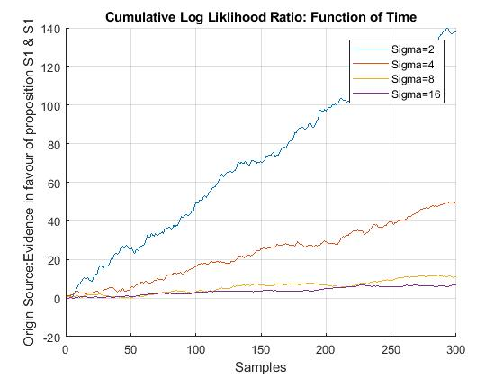

300 samples were generated from a normal distribution with a mean = -1 . Four unique batches of 300 samples were created with each batch varying its standard deviation between [2 4 8 16], whilst holding the priors constant at [0.5 0.5]. Figure 1 shows the effects of an increasing standard deviation on a random walk. Overall results show that as the standard deviation increases between the means of the S1 and S2 distributions, the value of cumulative log likelihood ratio decreases in turn. Considering that $ln\frac{x}{y}=\ln\left(x\right)-ln⁡(y)$, one can see that the probabilities of the current data point originating from either S1 or S2, $Log\frac{P(r|s1)}{P(r|s2}$ is assessed via an evaluation of difference through subtraction. Thus, if the probabilities are similar then the log output will generate a small difference, which will ultimately contribute little to the overall cumulative log likelihood ratio. Higher standard deviations generate smaller Log likelihood ratios the standard deviation of a distribution describes how representative the data points are of their respective distribution mean.

Continue To Next page

***Diagram 1: Overlapping Probability Density Functions****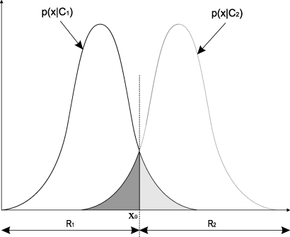*

Considering that the distributions of S1 and S2 are randomly sampled from two normal probability density functions. With increasing standard deviations, one observes larger overlaps and the two distributions begin to share similar probabilistic characteristics, with respect to the generation of S1 and S2 data points. As a result it becomes increasingly more probable that two distributions will contain more of the same values. The data points become increasingly less representative of their respective means and it becomes difficult for the model to discern which distributional mean each data point corresponds to too. Therefore data points that fall within the overlap region will have a similar probability of being generated from S1 or S2 distribution, when calculating the Log likelihood ratio. This is evidenced by figure 1 as one can see that the random walk with sigma = 16 accumulates less rapidly than random walks with lower sigma’s. In terms of perceptual decision making, higher standard deviations would increase a Bayesian observers uncertainty, indicating that more time, thus samples, is needed for the observer to accumulate more evidence in favour of S1 or S2, as evidenced by figure 2.

Continue To Next page

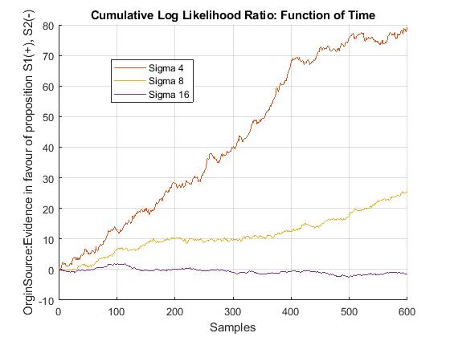***Figure 2: Effects of increased Sample size***

Thus far it has been shown that the standard deviation can significantly affect the dynamics of a random walk, by increasing the level of uncertainty experienced by a Bayesian observer. Nonetheless increased time to accumulate evidence can reduce uncertainty when the standard deviation is high between two distributions. However as shown by sigma 16 in figure 2 if the level of noise is high it may take a significantly large amount of time for the log likelihood posterior ratio to converge towards an S1 or S2 barrier, which ultimately may be in more realistic contexts impractical.

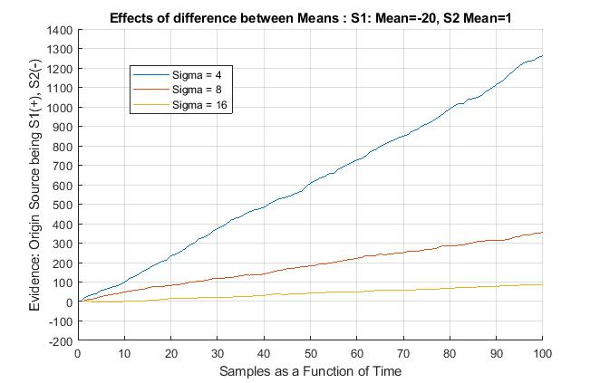***Figure 3: Effects of increased Difference Between Means***

Figure 3 shows how the effects of standard deviation on a random walk is relative to the characteristics of probability density functions that in which S1 and S2 sample from. No doubt it will require a far greater level of standard deviation to cause detrimental overlaps between two distributions if the difference between the two-respective means is large. This Comparing Sigma 8 and 16 in Figures 2 and 3 one can see how a greater distance between the means of S1 and S2 allows the random walks to accumulate towards much higher Log likelihood ratio values that are biased towards S1, over a much smaller sample/time range. Relating this back to perceptual decision making, it may be interesting to think that an observer may take advantage of the interplay between the mean and standard deviation of two distributions during a random walk. Consider a feature search task, as shown in diagram 2, in which the observer must Identify whether the target object is the same as the sequentially presented stimulus object. In task 1 the observer may attempt to identify the whether the two objects are the same based upon shape and size. In Diagram 2 the stimulus objects look very similar to the target object but in fact differ in size and shape by a fractional amount. Therefore although the objects are different their respective distributions in the feature space of shape will be highly similar, akin to that in question 2 where S1 (mean = -1, sigma =16) and S2(mean = 1, sigma =16). Due to the shape of the target and stimulus object the overlap between the distributions will be large and such noise will cause Log likelihood posterior ratios to be small, thus causing the random walk to iterate close to 0 and thus a high level of uncertainty, As shown in Diagram 2 this can be akin to the random walk sigma = 16 in image 1. Likewise, it may take considerable time/samples for the observer to collect enough data to hit the decision boundary. However, if the observer was able to switch their perceptual scope to the colour feature space the differences between the distributions of the target and the stimulus will be much larger, as the data points for each object with respect to colour will be sampled from two more distinguishable probability density functions. Overall this maybe be analogous to a random walk shown in image 2 sigma 16, where the object and target are sampled from two vastly different distributions (target: mean = 1, stimulus (mean = -20)) the log likelihood posterior ratios accumulate to the positive decision boundary, of the two objects being different, much more rapidly than when assessed in the shape feature space. Similar to how an observer may optimise the height of their decision boundaries through trial and error, it may be also possible that observes optimise which feature spaces are more likely to produce much more distinguishable S1 or S2 distributions, thus allowing them to make much more accurate and rapid responses during perceptual decision making.

Continue To Next page

***Diagram 2***:

Feature Search (Shape or Colour): Find The Shape that deviates from all others

Target

Stimulus Shown sequentially through time(T)



**Image 2**

**Image 1**



The effect Priors on the Dynamics of random Walk analysis:

***Figure 4: The effect of Priors when S = S1:100%***

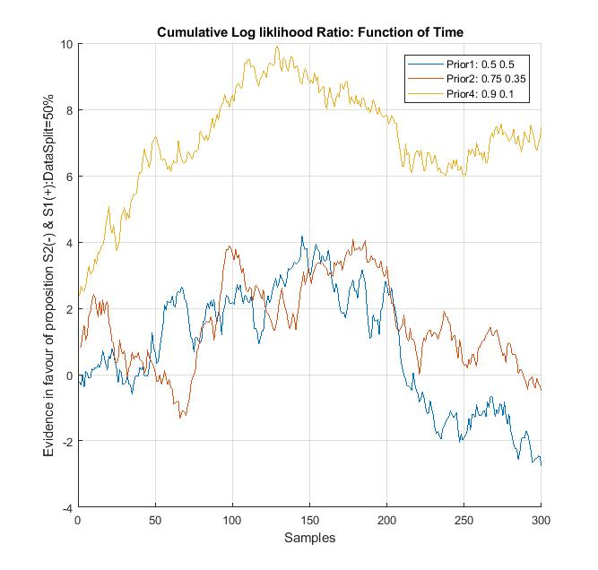

From Figure 4 one can see that the priors determine where each random walk will begin at samples/time= 0. Figure 4 shows the priors of S1(right prior) and S1(left Prior), the first 150 data points were generated from the S1 distribution and the remaining 150 samples were generated from S2. Considering that S1 occupies the positive regions whilst S2 occupies the negative regions, it is clear that as the prior probability of the signal belonging to S1 increases so does the initial log likelihood posterior ratio at time/sample = 0 for the random walk. This seems logical given that a prior represents an observer’s prior beliefs on the whether the signal originates from S1 or S2. Equally the figure shows that If an observer is 90% certain that the signal belongs to S1 then successive exposure of evidence that is in favour the prior belief will cause the random walk to rapidly increase towards a more the S1 decision barrier, than random walks that have smaller prior values towards S1. This due to rule of logs that $\ln\left(xy\right)=\ln\left(x\right)+ln⁡(y)$. First the probabilities of whether the sample stems from S1 or S2, with respect to the evidence, are assessed through subtraction, then the log of the difference between priors S1 and s2 and added on to the this, ultimately amplifying the amount in which the random walk shifts towards S1 or S2 by a factor of the magnitude of how much an observer’s prior is biased towards S1 or S2. Interestingly figure 4 also shows that despite the initial effects of the prior bias towards S1, a sufficient accumulation of alternate evidence over time, in favour of S2, will untimely drive the random walk down towards the negative S2 decision barrier. However higher priors towards S1 will descend the random walk much slower than random walks with smaller prior biases towards S1.

How can you influence participants’ prior experimentally?

* Before the start of the detection experiment, tell the participants what results to expect, although controlling the magnitude to which participants bias their prior beliefs towards S1 or S2 may be hard to quantify.
* Pre-train participant with a specific signal in which the origin of the signal is significantly biased towards being S1 or S2. This will pre-condition participants to expect similar results during the test, thus biasing their prior beliefs towards S1 or S2. Manipulation of prior beliefs maybe be quantified more easily, as the number of trails and percentage by which the origin of the training signal is biased towards S1 and S2 can be controlled.
* Prior beliefs may be influenced subliminally through subconscious suggestion, implicitly and explicitly obtained prior knowledge maybe accessed, manifest and operate differently.

**Question 3**

ii: Decision Barriers

The height of the barriers describes the trade-off between speed and accuracy. Higher barriers require the observer to spend more time gathering evidence, thus increasing the probability of making a correct decision. However lower barrier heights will allow the observer to decide with much lower reaction times, yet the probability of being correct will decrease significantly. Therefore, the barrier height will increase or decrease participant performance during an experiment.

It has been suggested that an observer will optimise the height of their decision barriers based upon the rate of reward for each experiment. The rate of reward is dependent upon probability of making a correct response and the average time spent per trial. Therefore, one could shift a participant’s barriers by experimentally manipulating the rate of reward and the of detection task. difficulty can be akin to manipulating the noise to signal ratio via increasing or decreasing the level of variance(sigma) or the distance(means) between the S1 and S2 distributions. If the participant can identify the signal correctly more often, due to lowered difficulty and they receive a reward on criterion of fast reaction times, one may observe that participants significantly lower the height of their decision boundaries, in favour of producing faster reaction times. Likewise rewards in favour of accuracy, in which the difficulty is hard may cause participants to drastically increase the height of their decision boundaries, trading of reaction times, to accumulate more data, to increase their probability of being accurate. In this context a reward in favour of reaction times will decrease barrier heights, whilst rewards in favour of accuracy will increase barrier heights. The magnitudes by which the participants reduces their barriers will be dictated by how difficult the task is, which as stated will increase or decrease the probability of generating a correct response. Nonetheless one’s priors may also effect the barrier height. Considering a set of experimental trails in which the reward is given on the basis of low reaction times, but the task is difficult. Participants that have prior beliefs strongly biased towards S1 or S2 being the correct signal may show much smaller barrier heights than participants with minimal prior dispositions. Nonetheless as shown in Question 2, there is an interplay between then priors and the accumulation of new evidence. Whereby priors will dictate the initial direction of the random walk, however if enough alternate evidence is gathered over time, this will ultimately lead the random walk to be driven towards decision boundary in favour of the evidence despite one’s strong prior beliefs for the alternate, albeit stronger priors will cause slower adaptations to the new evidence. Similarly, the height of the barriers may adapt in the same manner. In the initial stages of the experiment one’s priors will attempt to maintain the positions of the barriers S1 and S2, however if enough evidence is gathered over time that suggests similar probabilities of the signals origin being S1 or S2 will lead the participant to become more uncertain as the random walk tends towards 0. Likewise, as the evidence is now in contradiction to their prior beliefs, the observer may within trails increase the height of their barriers to allow for more evidence to be accumulate to increase their probability of being correct. The rate at which the barrier increase could be dependent on the level of uncertainty, smaller log posterior ratios close to 0 will increase the rate at which the observer expands their barrier heights in order to allow for sudden adaptation to accommodate to the unexpected. If this is so there maybe a push and pull relationship between the prior beliefs maintaining current barrier state, whilst new evidence attempts to cause change to the barrier state. Therefore on this basis barrier height could be experimentally manipulated by presenting participants, with and without strong priors, unexpected changes to the experiment parameters, for example unexpectedly increasing the difficulty to detect the signals origin for a certain batch of trials.

One final point that may change barrier height that has not been considered is patience as a function of time. Thus far random walks are modelled to proceed until a decisional barrier is hit. However some participants may only be willing to accumulate new evidence for a discrete period of time, at which point ones patience runs out, the participant maybe inclined to make their based guess at the origin of the signal or simply state that they don’t know the answer, and give up. It maybe so that decisional barriers may rapidly change one a participants patience threshold has been reached. For example a participant who are inclined/more decisive to make their best guess when their patience threshold has been reached may at this point rapidly decrease their barrier heights towards 0 until the S1 or S2 barrier hits the log likelihood posterior ratio, thus allow them to make a decision based on insufficient but the closest evidence obtained. Likewise participants who are less decisive or inclined to make a choice may rapidly expand their decision boundaries out towards infinity, thus prohibiting any decision to be made, in the time range the participants are willing to spend searching for an answer. This maybe shown as follows:

$$Rate of barrier change= \frac{1-P}{U}-T$$

The above simplistic model shows how the rate of change of the barrier height in response to patience. P is expressed as a probability and is dependent on the priors, more extreme priors such (P(S1) = 0.9, P(S2) = 0.1) and visa versa will yield high probabilities of P. P represents the probability at which a participant will attempt to maintain their previously established barrier states. U represents the level of uncertainty the participant is experiencing, which is the Euclidian distance between the current Log likelihood posterior ratio and 0 (0 represents the highest state of uncertainty) . Finally T represents a patience timer, it subtracts 0 from the rate of change of the barrier height until the a participants patience threshold is reached at which point it causes a rapid expansion or contraction of the heights of the decision barriers. T can be expressed as follows:

t = $Σ_{ti}+1 if t=p then T= Σ_{T}+\frac{1}{Id} else T=0$

$$P=S*Pp$$

Here P represents a participants patience threshold relative to the number of samples in an experiment. Pp is the probability that a participant will be willing to search the entire sample space (S) to find a decisional answer. For example someone who is 60% likely to search the entire sample space of 300 samples has a patience threshold of 0.6 * 300 = 180 samples. t represents an internal timer that counts per sample until the patience threshold is reached. ID then represents a measure of participants decisiveness on a scale of 0 to 1, where 1 represents complete indecisiveness and 0 complete decisiveness. As it is assumed that decisiveness participants will be more inclined to make a best guess when they have run out patience, a small ID such as 0.1 will create large value of T and create a positive exponential curve and drive the value of T downwards towards 0 that will ultimately cause the barriers to contract. Likewise participants one are indecisiveness are assumed to not be able to make any decision if the patience threshold has been reached before a decision barrier. Therefore large values of ID will generate increasingly more negative values of T which will drive the rate of barrier height change up and cause them to expand towards infinity. The rate of such change in barrier height is determined by the magnitude of indecisiveness or ID.

Although the above proposed model is very simplistic it demonstrates the point that barrier height maybe highly dynamic to changes in Particpants patience and there priors states.